**Electric-drive Vehicle Modeling and Simulation**

**Assignment 2) Punit Purohit (GD7198)**

**Validation of given car model and Calculations**

**Drive Cycle 505**

1. 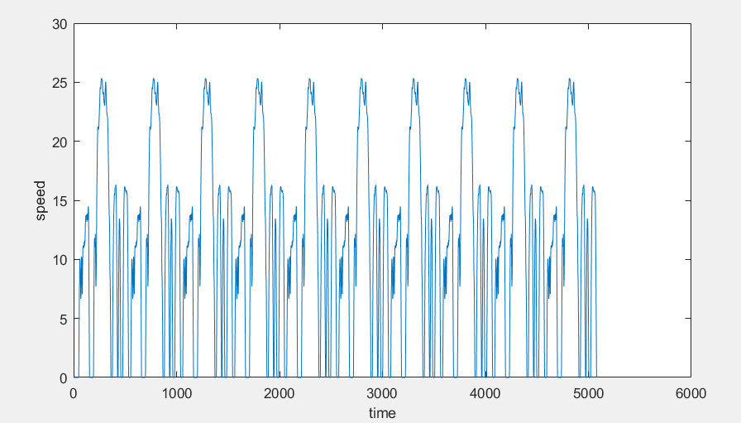**Input**

The input speed vs time plot looks proper with total 10 cycles. It should provide sufficient distance of travel to test both CD range and CS.

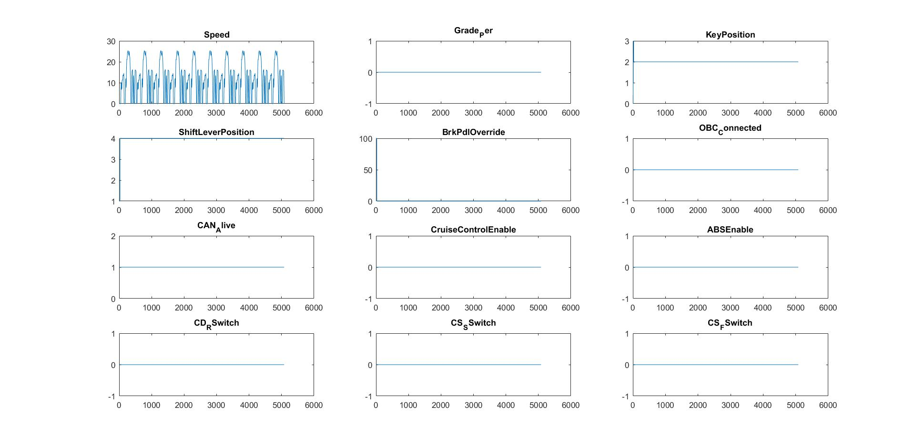

**Simulation Results**

After some debugging and changes that are described later, the model simulation ran.

Following results were obtained

**First Analysis:**

At first sight, the results seem very proper and as expected, the velocity curve matches closely to the input drive cycle, the engine speed is zero until the SOC drops to 18% at about 2800 seconds and then 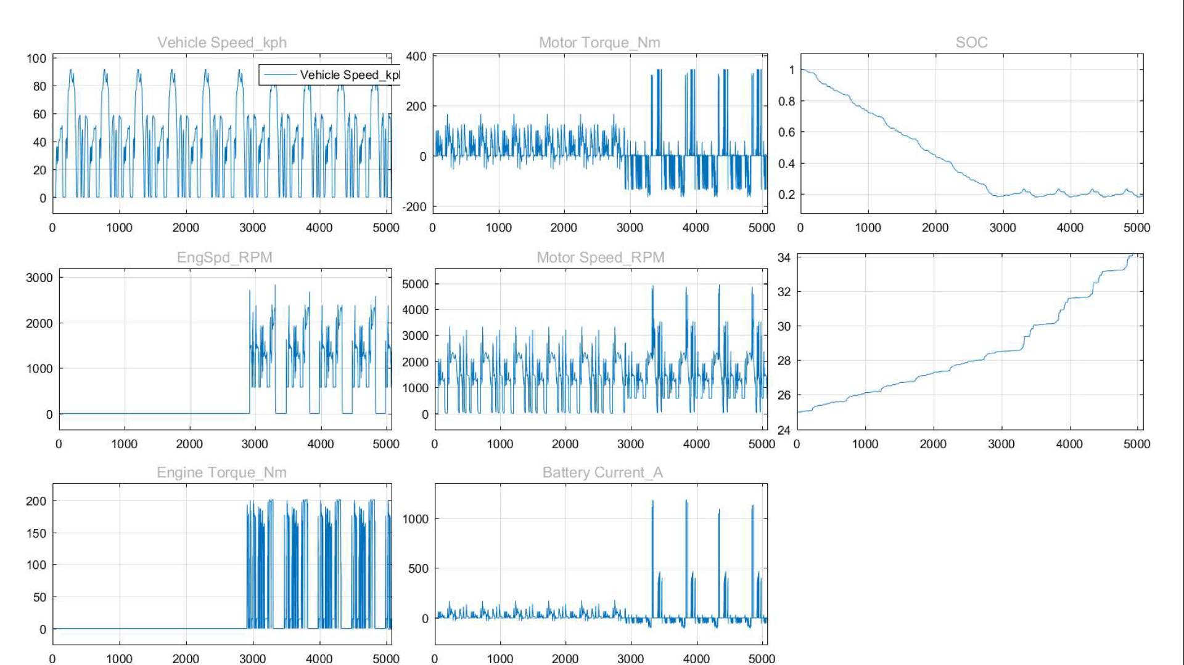the engine speed picks up showing the start of the engine. There are four time in the plot where engine speed reaches zeros and stays their 100 -200 secs this shows that the battery is charged to the required state and is now running on battery only for that time. Similar trend can be seen in engine torque.

Motor Torque also similar to the expected curve going below zero few time representing regenerative braking and shows almost continuous negative while the engine is running and positive torque again at times when the engine stops. The spike in the motor torque in charge sustaining mode is questionable and requires deeper inquisition, Similar trends can be seen in Battery Current with same spike in battery current in CS mode.

CD range and CS mode can be clearly seen in the SOC plot, the car runs on battery until it reaches 0.18 SOC and then the engine kicks in and starts charging the battery and running the car till the battery reached a 0.23 SOC value after which the engine shuts down and then this goes on in loop

Calculations

**CD Range** calculation is done after each drive cycle simulation in the simple way.

The SOC percent history and distance history against time is logged in two variables the code shown below picks the time when the SOC reaches min SOC percentage and picks the distance traveled until that time from the distance history variable

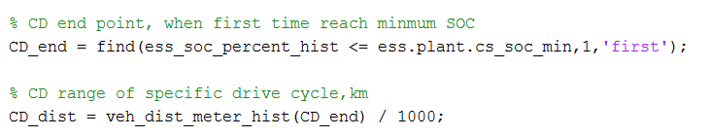**CS Distance** is calculated by measuring the time when the SOC last reaches its minimum value and the distance is traveled till this time from the CD end time.

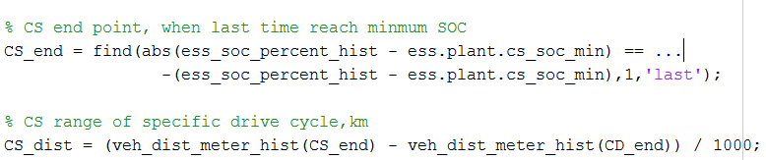

**Charge‐Sustaining Energy Consumption** is calculated using formula:

Since the SOC percentage in 18.5854 at start and 18.5258 at the end of drive cycle hence the CS is **SOC neutral** and hence the formula can be changed to:

Fuel consumption is calculated using above formula and then multiplied by weighting factor.

**Drive Cycle - Hwfet:**

**Input:**

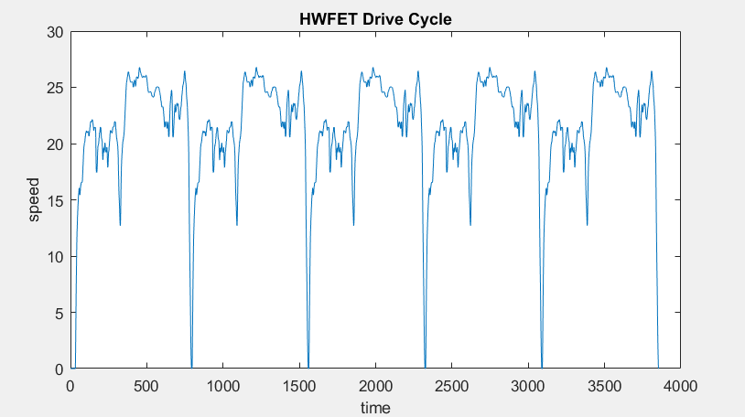

**Results:**

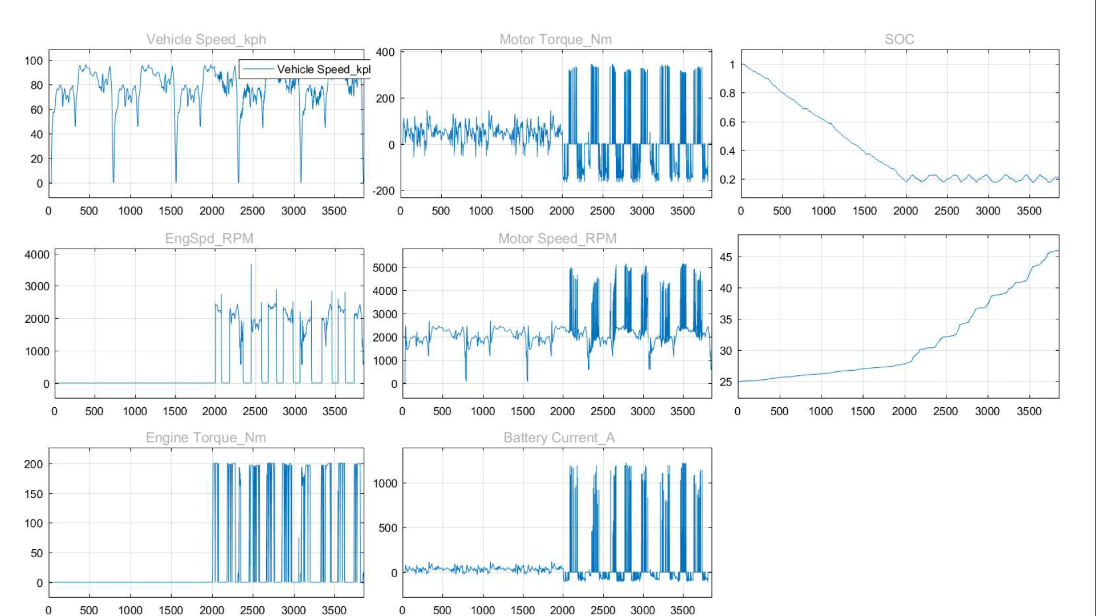

Everything follows the same pattern as the 505 drive cycle the CD range ends at about 2000 secs and then the engines start to support it can also be seen that **CD mode is EV‐only**. Since the same script is ran the calculation are also similar only the weighing factor has changed.

**Drive Cycle US60City:**

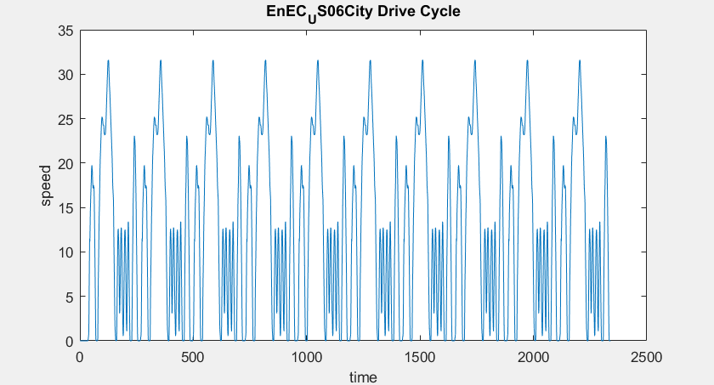

**Result:**

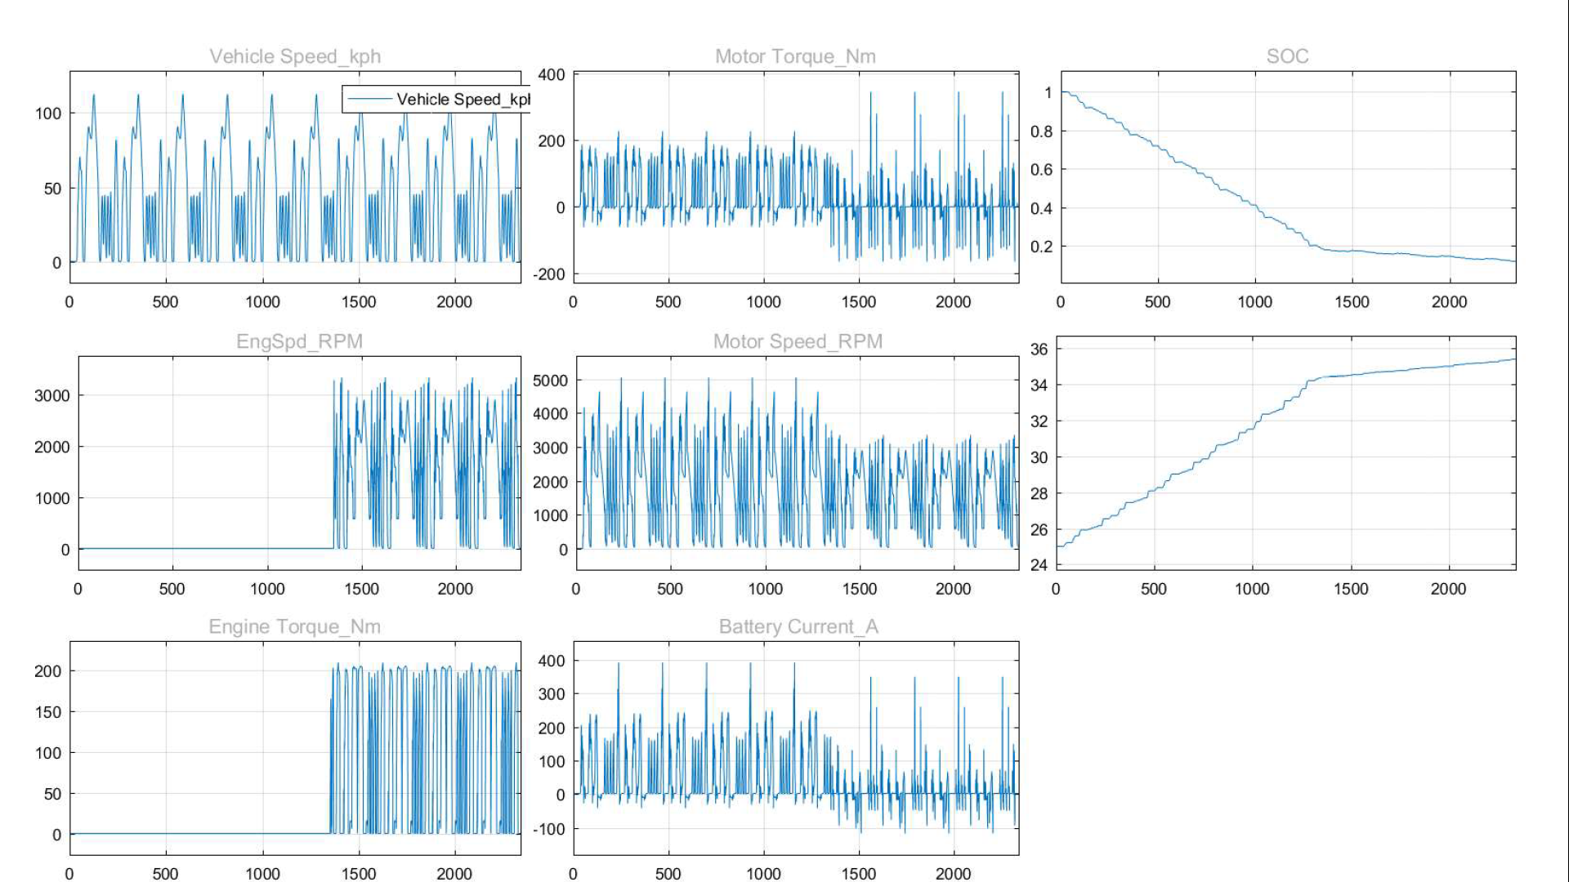

**Dirve Cycle : US06Hwy**

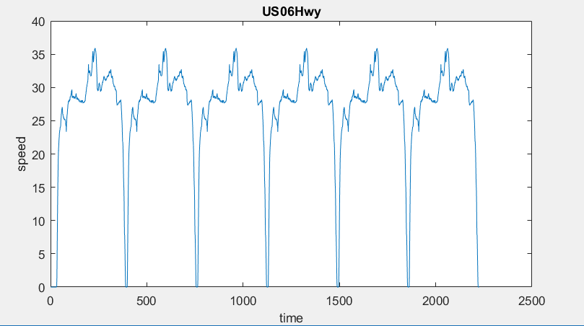

**Results:**

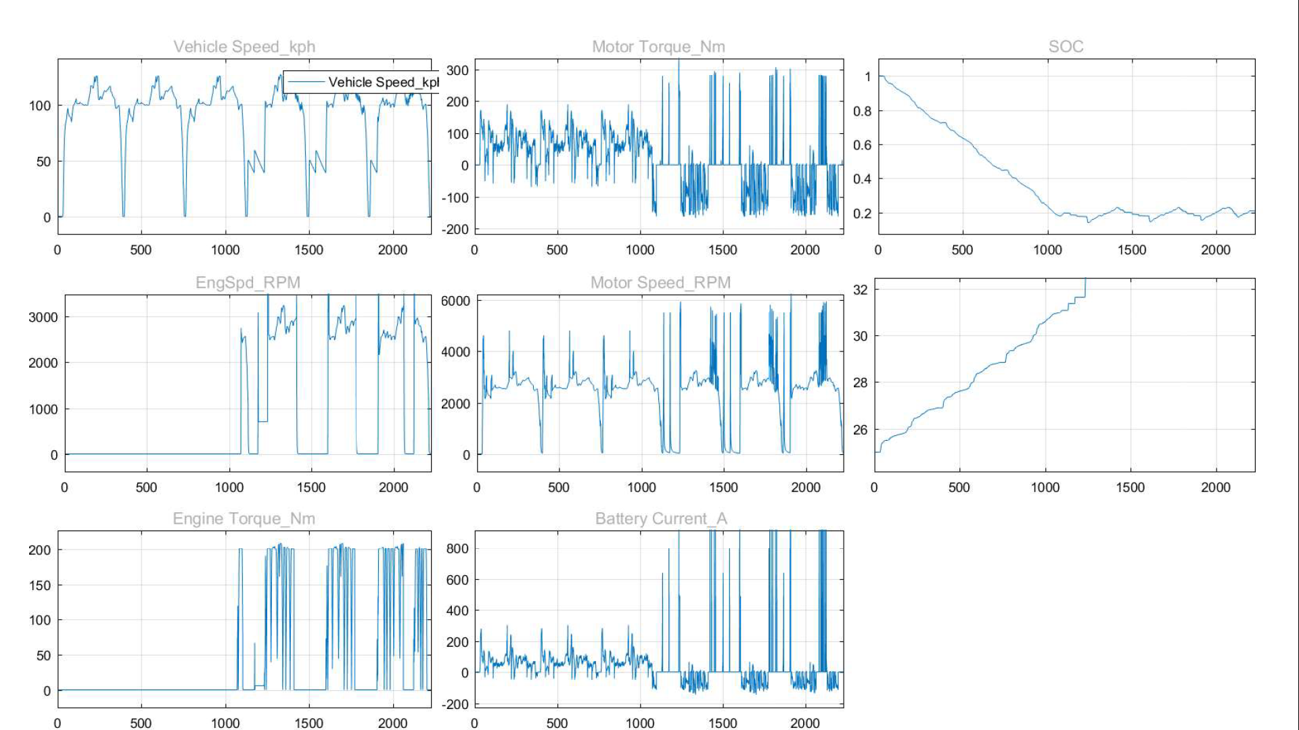

It can also be seen that the CD range on highway is 28.65 km and in city is 16.12 Km which is expected this further increases our Confidence in the model.

**Emission and Energy Consumption Calculations**

**Approach 1:**

After getting data from all the simulations post calculations for approach 1 is done in **‘EnEC_Calculation_post.m’** file the method used is as described below.

The weighted energy consumption is received from all cycles and a summation for weighted CD electric consumption is obtained similarly Summation of CS fuel Consumption is obtained .

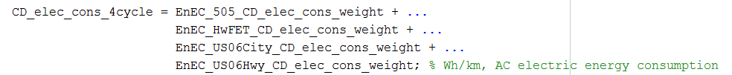

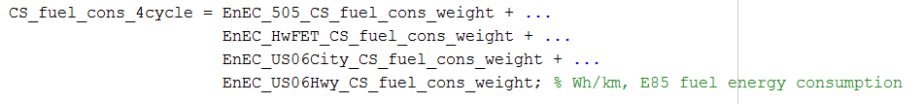

**UF** is calculated using this summed weighted CD range using

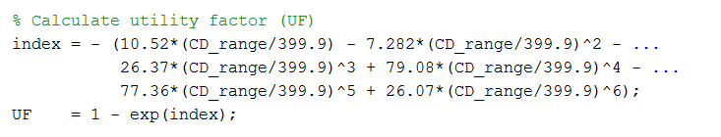

**UF Corrected energy consumption** is calculated by:

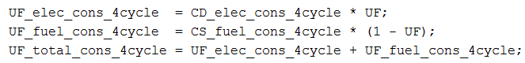

**Petroleum energy use**

PEU factor values are taken form values give in table in presentation.

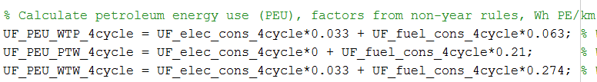

**Greenhouse gas emission (GHG)**

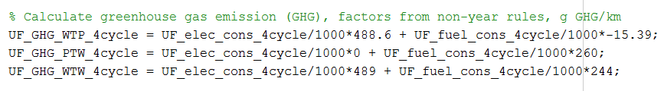

**Approach 2:**

In Second approach **UF weighted** and factor ECCD ,ECCS and ECtotal is calculated of each cycle in pre-calculations(in ‘Approach2PreCalculation.m’ file) and saved.

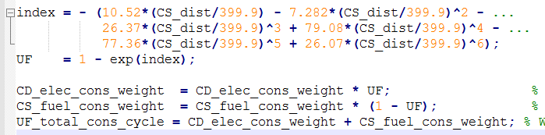

These values are summed for each cycle and UF is calculated from formula

From this CD-range is estimated using lookup table from this UF value.

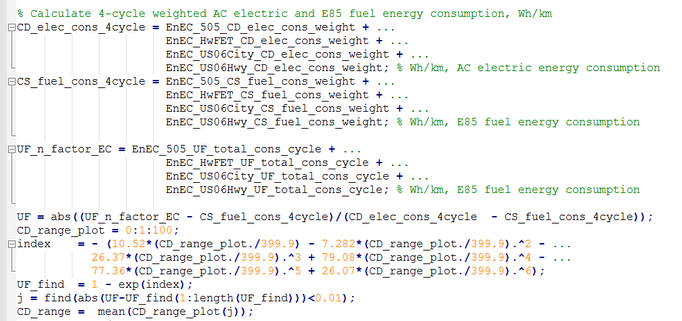

**Improvement on the current scripts and approaches**

To improve computation procedure functionalities and efficiencies, a function to use the older simulation results have been added to the new created GUI, it enables the user to try different computational algorithms to get results using same simulation data hence saving a major chunk of time that is taken by Simulink, A simpler GUI is designed so that running the model is easier.

The Simulink model provided for this assignment uses only single core of the PC, if multiple-core programming is used the time taken for simulation can be reduced n to less than half.

Step 4) **Another approach:**

To calculate cd range one cycle data can be extrapolated to reach minimum SOC percentage the data for each cycle can then we factor weighted and averaged to find UF value and then the further approach is similar as approach 1.

Using single cycle data for CD range:



Using Single cycle data in CS mode

In the above two approaches there is no exact distance given for calculation and hence these are not standardized. the simulation time can be limited by an exact amount of distance travelled or by fuel capacity. This will provide a stand distance over which the calculations are performed.

**Vehicle Technical Specifications:**

|  |  |  |  |  |
| --- | --- | --- | --- | --- |
| Specification | Units | WSU | Approach 1 | Approach 2 |
| CD Mode Range* | km | 26 | 24.91 | 15 |
| CD Mode Total *Energy Consumption* (EC) | Wh/km | 257 | 218 | Integrated approach |
| CS Mode *Fuel Energy Consumption* (FC) | Wh/km | 619 | 696 | Integrated approach |
| UF‐Weighted Fuel Energy Consumption | Wh/km | 310 | 373.95 | 393.44 |
| UF‐Weighted AC Electric Energy Consumption. | Wh/km | 122 | 101 | 93.602 |
| UF‐Weighted Total Energy Consumption | Wh/km | 434 | 475 | 487 |
| UF‐Weighted Total Energy Consumption | mpgge | 48.3 | 44.13 | 43.04 |

Instructions to run the model is provided in previous submission.

Although the two approaches give relatively similar results but the percentage difference in the two are very significant (like 30% difference in UF value). This difference is because of the exponential powers involved in the formulas with magnifies small errors. Other values are very close to the solution.